Print Out Source Code Program

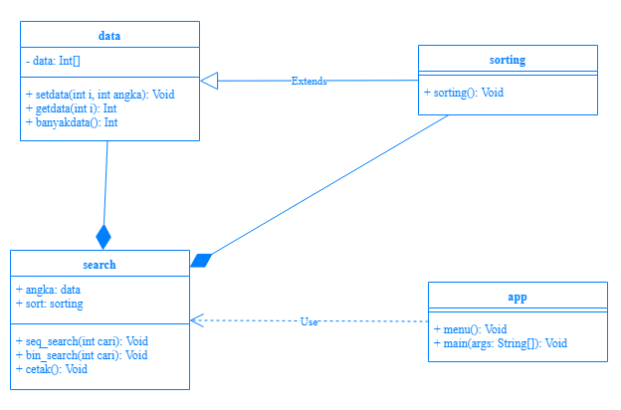

Print Out Source Code Program

public class data {

private int[] data = new int[10];

public void setdata(int i, int angka) {

this.data[i] = angka;

}

public int getdata(int i){

return data[i];

}

public int banyakdata(){

int banyak = data.length;

return banyak;

}

}

Keterangan Source Code :

------------------------------------------------------------------------------------------------------------------------------------------------------------------------------------------------------------------------------------------------------------------------------------------------------------------------------------------------------------------------------------------------------------------------------------------------------------------------------------------------------------------------------------------------------------------------------------------------------------------------------------------------------------------------------------------------------------------------------------------------------------------------------------------------------------------------------------------------------------------------------------------------------------------------------------------------------------------------------------------------------------------------------------------------------------------------------------------------------------------------------------------------------------------------------------------------------------------------------------------------------------------------------------------------------------------------------------------------------------------------------------------------------------------------------------------------------------------------------------------------------------------------------------------------------------------------------------------------------------------------------------------------

Print Out Source Code Program

public class sorting extends data{

void sorting() {

System.out.println("\nHasil Sorting: ");

int temp, kecil;

for(int i = 0; i < 10 ; i++){

kecil = i;

for(int j = i+1; j < 10; j++){

if (getdata(j) < getdata(kecil))

kecil = j;

}

temp = getdata(i);

setdata(i,getdata(kecil));

setdata(kecil, temp);

}

}

}

Keterangan Source Code :

------------------------------------------------------------------------------------------------------------------------------------------------------------------------------------------------------------------------------------------------------------------------------------------------------------------------------------------------------------------------------------------------------------------------------------------------------------------------------------------------------------------------------------------------------------------------------------------------------------------------------------------------------------------------------------------------------------------------------------------------------------------------------------------------------------------------------------------------------------------------------------------------------------------------------------------------------------------------------------------------------------------------------------------------------------------------------------------------------------------------------------------------------------------------------------------------------------------------------------------------------------------------------------------------------------------------------------------------------------------------------------------------------------------------------------------------------------------------------------------------------------------------------------------------------------------------------------------------------------------------------------------------

Print Out Source Code Program

public class search {

data angka = new data();

sorting sort = new sorting();

void seq_search(int cari){

int found = 0;

for(int i=0; i<10; i++){

if(sort.getdata(i) == cari){

found = i+1;

}

}

if(found == 0){

System.out.println("\nData Tidak Ada");

}else{

System.out.println("\nData ada di index-"+found);

}

}

Keterangan Source Code :

------------------------------------------------------------------------------------------------------------------------------------------------------------------------------------------------------------------------------------------------------------------------------------------------------------------------------------------------------------------------------------------------------------------------------------------------------------------------------------------------------------------------------------------------------------------------------------------------------------------------------------------------------------------------------------------------------------------------------------------------------------------------------------------------------------------------------------------------------------------------------------------------------------------------------------------------------------------------------------------------------------------------------------------------------------------------------------------------------------------------------------------------------------------------------------------------------------------------------------------------------------------------------------------------------------------------------------------------------------------------------------------------------------------------------------------------------------------------------------------------------------------------------------------------------------------------------------------------------------------------------------------------

Print Out Source Code Program

void bin_search(int cari){

sort.sorting();

cetak();

int awal = 0, akhir= sort.banyakdata()-1, found=0;

for(int i = 0; i < sort.banyakdata(); i++){

int tengah = (akhir-awal)/2;

if(sort.getdata(i) == cari){

found = i+1;

}else if(sort.getdata(tengah) > cari){

akhir = tengah - 1;

}else{

awal = tengah+1;

}

}

Keterangan Source Code :

------------------------------------------------------------------------------------------------------------------------------------------------------------------------------------------------------------------------------------------------------------------------------------------------------------------------------------------------------------------------------------------------------------------------------------------------------------------------------------------------------------------------------------------------------------------------------------------------------------------------------------------------------------------------------------------------------------------------------------------------------------------------------------------------------------------------------------------------------------------------------------------------------------------------------------------------------------------------------------------------------------------------------------------------------------------------------------------------------------------------------------------------------------------------------------------------------------------------------------------------------------------------------------------------------------------------------------------------------------------------------------------------------------------------------------------------------------------------------------------------------------------------------------------------------------------------------------------------------------------------------------------------

Print Out Source Code Program

if(found == 0){

System.out.println("\nData Tidak Ada");

}else{

System.out.println("\nData ada di index-"+found);

}

}

void cetak(){

for(int i=0; i<10; i++){

System.out.println(sort.getdata(i));

}

System.out.println("");

}

}

Keterangan Source Code :

------------------------------------------------------------------------------------------------------------------------------------------------------------------------------------------------------------------------------------------------------------------------------------------------------------------------------------------------------------------------------------------------------------------------------------------------------------------------------------------------------------------------------------------------------------------------------------------------------------------------------------------------------------------------------------------------------------------------------------------------------------------------------------------------------------------------------------------------------------------------------------------------------------------------------------------------------------------------------------------------------------------------------------------------------------------------------------------------------------------------------------------------------------------------------------------------------------------------------------------------------------------------------------------------------------------------------------------------------------------------------------------------------------------------------------------------------------------------------------------------------------------------------------------------------------------------------------------------------------------------------------------------

Print Out Source Code Program

import java.util.Scanner;

public class app{

public static void main(String[] args) {

search data = new search();

Scanner in = new Scanner(System.in);

data.sort.setdata(0, 1);

data.sort.setdata(1, 4);

data.sort.setdata(2, 12);

data.sort.setdata(3, 15);

data.sort.setdata(4, 25);

data.sort.setdata(5, 33);

data.sort.setdata(6, 3);

data.sort.setdata(7, 20);

data.sort.setdata(8, 19);

data.sort.setdata(9, 21);

Keterangan Source Code :

------------------------------------------------------------------------------------------------------------------------------------------------------------------------------------------------------------------------------------------------------------------------------------------------------------------------------------------------------------------------------------------------------------------------------------------------------------------------------------------------------------------------------------------------------------------------------------------------------------------------------------------------------------------------------------------------------------------------------------------------------------------------------------------------------------------------------------------------------------------------------------------------------------------------------------------------------------------------------------------------------------------------------------------------------------------------------------------------------------------------------------------------------------------------------------------------------------------------------------------------------------------------------------------------------------------------------------------------------------------------------------------------------------------------------------------------------------------------------------------------------------------------------------------------------------------------------------------------------------------------------------------------

Print Out Source Code Program

System.out.println("Data:");

data.cetak();

int cari;

System.out.print("Masukkan Angka: ");

cari = in.nextInt();

System.out.println("Pilihan Cari\n1.Sequential search\n2.Binary search\nPilih ");

int pilih = in.nextInt();

switch(pilih){

case 1:

data.seq_search(cari);

break;

case 2:

data.bin_search(cari);

break;

}}

Keterangan Source Code :

------------------------------------------------------------------------------------------------------------------------------------------------------------------------------------------------------------------------------------------------------------------------------------------------------------------------------------------------------------------------------------------------------------------------------------------------------------------------------------------------------------------------------------------------------------------------------------------------------------------------------------------------------------------------------------------------------------------------------------------------------------------------------------------------------------------------------------------------------------------------------------------------------------------------------------------------------------------------------------------------------------------------------------------------------------------------------------------------------------------------------------------------------------------------------------------------------------------------------------------------------------------------------------------------------------------------------------------------------------------------------------------------------------------------------------------------------------------------------------------------------------------------------------------------------------------------------------------------------------------------------------------------

Print Out Source Code Program

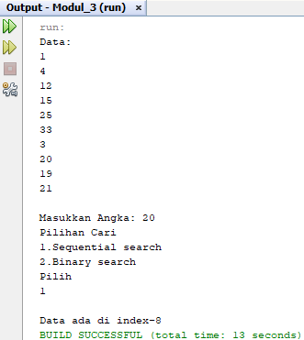

Keterangan Source Code :

-----------------------------------------------------------------------------------------------------------------------------------------------------------------------------------------------------------------------------------------------------------------------------------------------------------------------------------------------------------------------------------------------------------------------------------------------------------------------------------------------------------------------------------------------------------------------------------------------------------------------------------------------------------------------------------------------------------------------------------------------------------------------------------------------------------------------------------------------------------------------------------------------------------------------------------------------------------------------------------------------------------------------------------------------------------------------------------------------------------------------------------------------------------------------------------------------------------------------------------------------------------------------------------------------------------------------------------------------------------------------------------------------------------------------------------------------------------------------------------------------------------------------------------------------------------------------------------------------------------------------------------------------

Print Out Source Code Program

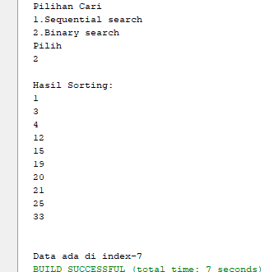

Keterangan Source Code :

-----------------------------------------------------------------------------------------------------------------------------------------------------------------------------------------------------------------------------------------------------------------------------------------------------------------------------------------------------------------------------------------------------------------------------------------------------------------------------------------------------------------------------------------------------------------------------------------------------------------------------------------------------------------------------------------------------------------------------------------------------------------------------------------------------------------------------------------------------------------------------------------------------------------------------------------------------------------------------------------------------------------------------------------------------------------------------------------------------------------------------------------------------------------------------------------------------------------------------------------------------------------------------------------------------------------------------------------------------------------------------------------------------------------------------------------------------------------------------------------------------------------------------------------------------------------------------------------------------------------------------------------------